

Interactive Graphics

Nome progetto

Ludovico Ottobre 1712005

Gianmarco Evangelista 171181

Contents

1  Introduction

2  Three.js: environment and scene

3  Shooting Range

4  Space Gun

5  Bowling

5.1 Physijs: plugin for Three.js

5.2 Functions and functionality

6  User’s interactions   
 6.1 Audio

6.2 Controls Menu

6.3 Resizing the window

6.4 Commands

7 Bibliography

1. Introduction

The project chosen to satisfy all requirements is a video game in which you can simulate the possibility to shoot a target in several modes. The user experience consists in to accessing in three modality in order to hit a target.

Every chosen gives to user the possibility of being in a different background scene maintaining the main idea of the game. In particular we can find three different situation and each one will have a different execution, animation, background and models.

The user can control the gun in the first and second approach while in the third he can use the ball in order to drop targets.

In the first scene, the user’s visual is in first person and he can manage a gun in order to hit a target as the traditional situation. Initially we have a number of hit equal to ten and at the end of the level, we will have the results: accuracy, perfect target hit, target hit or missed target. In order to achieve the second level, where we will have a different scene with a target between obstacles (trees and ducks), we have to achieve a minimum level of accuracy. If the second level accuracy is enough to pass the level difficulty, then the user can access to the third level in order to get the victory. In the third level we have more trees and ducks in order to create difficulties to user.

In the second scene, we don’t have any type of level but we can see a different background scene, different gun and a different target animation. In order to see the stats, we have a timer and at the end of it, after 20 seconds, the system returns the number of hit, the number of target hit and the accuracy. In particular in this scene we can find some planets as a background that are animated moving in place and a gold star that is the target to hit.

In the third scene we wanted to simulate the game of bowling through the effects of physics provided by physijs. The game is not composed of more levels but gives the user the possibility to try again to shoot to measure their skills.

In order to play, for each modality you have to use easily the mouse in order to hit the target and know that during the game by pressing the H key, you can return to home. All the others user interactions, are available in the menu on the right where you can set the light properties and choose whether to turn on or not the music.

2. Three.js: environment and scene

Three.js is a cross-browser JavaScript library and application programming interface (API) used to create and display animated 3D computer graphics in a web browser using WebGL.

In order to display anything with three.js we need three things: renderer, scene and camera. So we have created two functions:

createRenderer( )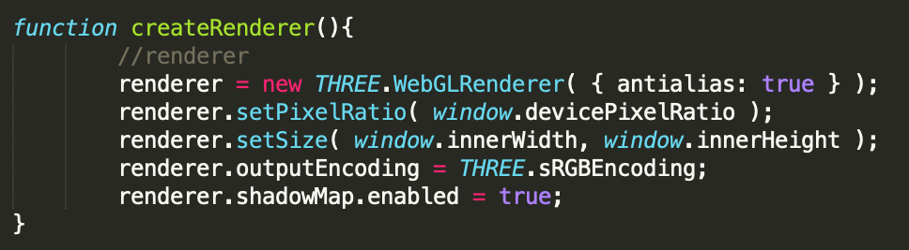

In addition to creating the renderer instance, we also need to set the size at which we want it to render our app. It's a good idea to use the width and height of the area we want to fill with our app - in this case, the width and height of the browser window. For performance intensive apps, you can also give setSize smaller values. For any heavy three.js app setPixelRatio( ) is the right way in order to don’t have a slow framerate. In the WebGL renderer we set the parameter anti-alias at true so that we can reduce jaggies (something like lines that should be smooth but they are not due to the not enough resolution of the device monitor) by surrounding them with gray- scaling.

createScene( ):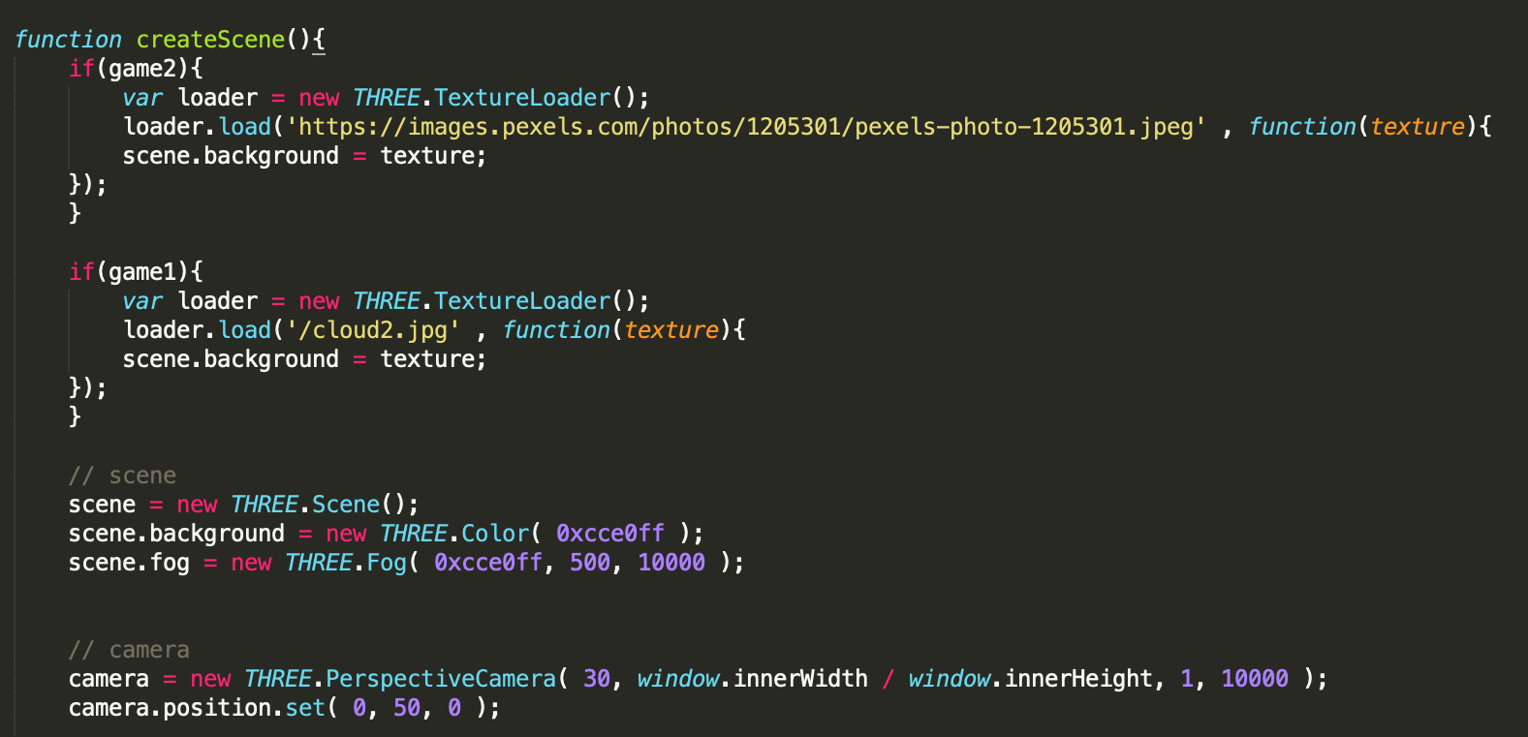

Camera:

The first attribute is the field of view. FOV is the extent of the scene that is seen on the display at any given moment. The value is in degrees.

The second one is the aspect ratio. You almost always want to use the width of the element divided by the height, or you'll get the same result as when you play old movies on a widescreen TV - the image looks squished.

The next two attributes are the near and far clipping plane. What that means, is that objects further away from the camera than the value of far or closer than near won't be rendered. You don't have to worry about this now, but you may want to use other values in your apps to get better performance.

Next up is the renderer. This is where the magic happens. In addition to the WebGLRenderer we use here, three.js comes with a few others, often used as fallbacks for users with older browsers or for those who don't have WebGL support for some reason.

Scene:

Scene allow us to set up what and where is to be rendered by three.js. This is where we have placed objects, lights and cameras.

Finally we have to talk about objects and models in the scene: these objects are classified as Mesh objects. Mesh class represents triangular polygon mesh based objects, that are a collection of vertices, edges and faces that defines a 3D model.

A Mesh object takes as input two parameters: geometry and materials objects.

In order to put a texture for each object, we have to use TextureLoader, a class for loading texture. This uses the ImageLoader internally for loading files.

The scene is an object that allows to set up all those things we want to be rendered, so for example objects’ models, lights and camera.

About the lights we added two:

1. Ambient Light
2. Directional Light

The second one can be set through the controls menu that appears during the game on the right. The user can decide to turn on or turn off the directional light, can choose whether to turn it on or not and can pause the general music. Through the function initGui( ), we have set the param and added them to var gui in order to manage each slider and button.

3. Shooting range

In order to implement this game, we have to use some functions and several models. It is divided in three different level, each one with a different difficulty and in order to achieve a good result is necessary that the user gets a specific accuracy values in general:

First Level > 0.5, Second Level >0.7, Third Level > 0.9.

We can divide the execution of the game deciding how many hits the user will have for each level and at the end of each one, he can decide whether to go on or stop himself.

The implementation of the gun has been done with the function *createGun( )* where we have used MTLLoader( ), a loader for loading an .mtl resource, used internally by OBJLoader that is a loader for loading a .obj resource and the OBJ file format is a simple data-format that represents 3D geometry in a human readable format as the position of each vertex, the UV position of each texture coordinate vertex, vertex normals, and the faces that make each polygon defined as a list of vertices, and texture vertices.

In order to load a texture, we have used THREE.TextureLoader( ), specifying what is the right pattern to load what we want. In order to manage in the right way the texture setting, it is important to know that we have used a hierarchical model and so for the remaining part hence through each child, we could realise the model. Thanks to animateCloseHammer( ) and animateOpenHammer( ), it has been set the animation of the trigger during the function fire( ) in order to give to user the feeling of reality.

In the same way we have created the ground, using createGround( ) function through TextureLoader, we have loaded the right texture and repeat it in order to cover all the scene.

The function fire( ), has been implemented in order to manage the user hits. When the cursor intersect the right element, in this case the target, we have to make a distinction based on which part of target we was taken. Through to intersects[0].object.name, if the element is equal to “low_for_paint_obj:polySurface1”, user’s score will increase of one, if it is equal to “Cylinder”, user’s score will increase of three while if the element hit is equal to “corpo”, the score will decrease of one since he takes a duck.

Inside of each if, we call the functions check( ) and respawn( ). In order to update the level value and the score value, we have created others two functions: updateLevel(x) and updateHTML(x) to get the element by ID and write a new variable x on the screen.

Thanks to createTree( x, y, z) and createBird( x, y, z), we could add to scene several of these model, understood as obstacles, in order to increase the difficulty of the game for each level. While in createTree we have easily add the model doing everything in the standard way, for the duck model we have planned the hierarchical model in order to set in the right way the texture and to make management easy. Through to animateBird( ), we managed the animation of the duck from the alternation of the legs to the ability to go back when it has crossed the entire space available, making a rotation on itself.

In order to create a target, we have created createTarget( x, y, z ). Taking an OBJLoader, we have added to it the right model and through the THREE.MashBasicMaterial, we have decided how to set the texture. Obviously a child called Cylinder, it has been set with a different material. The target is an external model that was implemented with our model in order to obtain a cylinder to have an area thanks to which we can distinguish the user hits in the right way.

The createMovingTarget( x, y, z ) function, is a function used to give to object the direction in order to move it. These two functions are called inside the function respawn( ). Thanks to respawn( ), we have the possibility to create, after that the target has been hit, a new target where the parameters of createTarget and createMovingTarget are generated by Math.random.

In function check( ), we have planned all we need in order to manage the levels. The way adopted was to use a precise number of possible shots for each level, using the var caricatore. At the end of a given number of shots, we can calculate the accuracy given by [ number of target hit/number of available shots ]. If this value will be major than 0.5, when I will see a window where I can read all of my stats, I can decide to go to the next level, otherwise I have to return home. The same approach will be adopt for each level. We have to remember that the accuracy result is calculated considering the sum of each level, starting from the first, so a bad result in the first level, even if gives you the possibility to go on, it won’t be enough to win the game. Obviously if you don’t achieve an accuracy in order to go on, you have only the possibility to restart.

For each level, we add new objects like trees and ducks in order to increase the difficulty thanks to the functions createBird( x, y, z ) and createTree( x, y, z ).

onMouseDown( evt ) and onMouseMove( ) are two functions and the first one is used to call the function fire( ), while the second function is used to manage the gun position based on the cursor direction.

Using onepoint(x, y) and threepoints(x, y), based on which part of target the user hits, we have used THREE.FontLoader( ) and THREE.TextGeometry in order to show a writing that will have a position depending on where the target was hit. If user hits the cylinder (the red part), he will have 3 points. Negativepoint( ) assigns, should the user catch the duck, a score equal -1 while onepoint( ) marks a score value equal to 1.

4. Space Gun

In this scene we don’t have levels to overcome but, even if the base results equal to the first game, in this case we find a different different star model, the presence of some planets during the game that works as obstacles and a star to hit. The goal is to achieve a perfect accuracy.

In order to realise this scene, we have used first of all the createStarGun( ) function to create the right model that will be used by the user in first person with the same interactive of the first scene.

Whenever the user clicks on the mouse, enable the function fire( ), thanks to which we could update the user’s score if the star was it. Playing, we can notice that for each shoot that goes to target, appears a line implemented with starfire( x ) where, using THREE.Geometry( ) and THREE.LineDashedMaterial( ), we have created a powerLine = new THREE.Line(powerLineGeometry, powerLineMaterial);. The line appears and will be eliminated from the scene thanks to removestarfire( ).

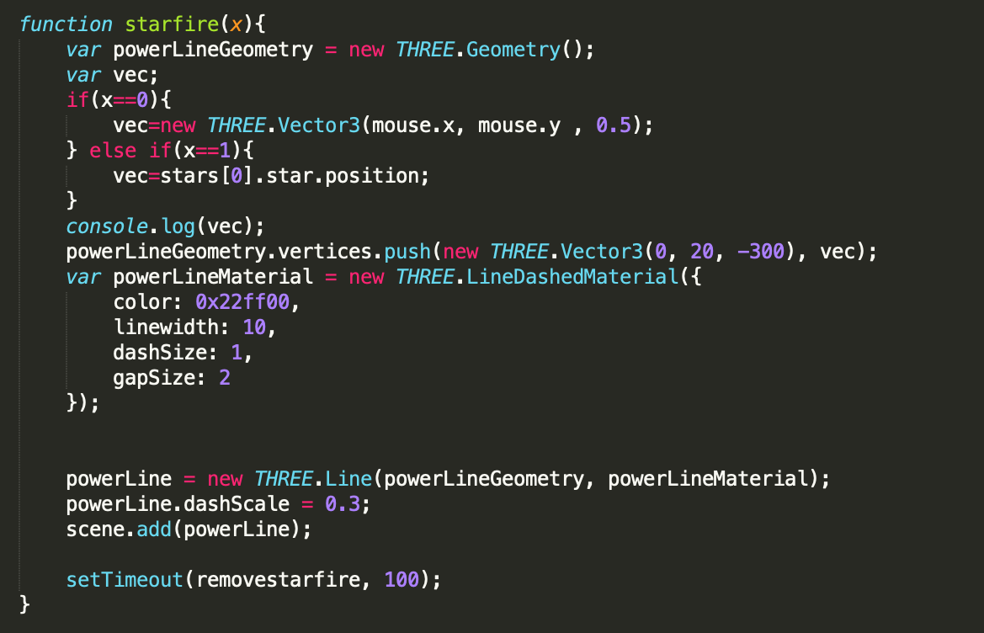

The star model is created by calling createStar( x, y), where the parameters establish the position of the target in the space. Every time that we want to create a new star, we have to pass it the parameters and this is done by Math.random. Like all the model, even the star model is imported using an MTLLoader( ) and the loading on this element the right gold star. After that, has been set the material.

Whenever that the user enables the function fire( ), if the target has been hit, with starfire( ), is called respawnStar( ) function in order to show a new star using the function createStar( x, y ).

Inside of we can find the management of the window shown with all the stats provide to user at the end of the game.

With createPlanets( ), we have taken a model composed by nine planets and through the function traverse we went to identify the children of the model that are equivalent to the nine planets associating each child to a variable that was subsequently managed within animate( ) where each planet will have its own animation and therefore its own rotation.

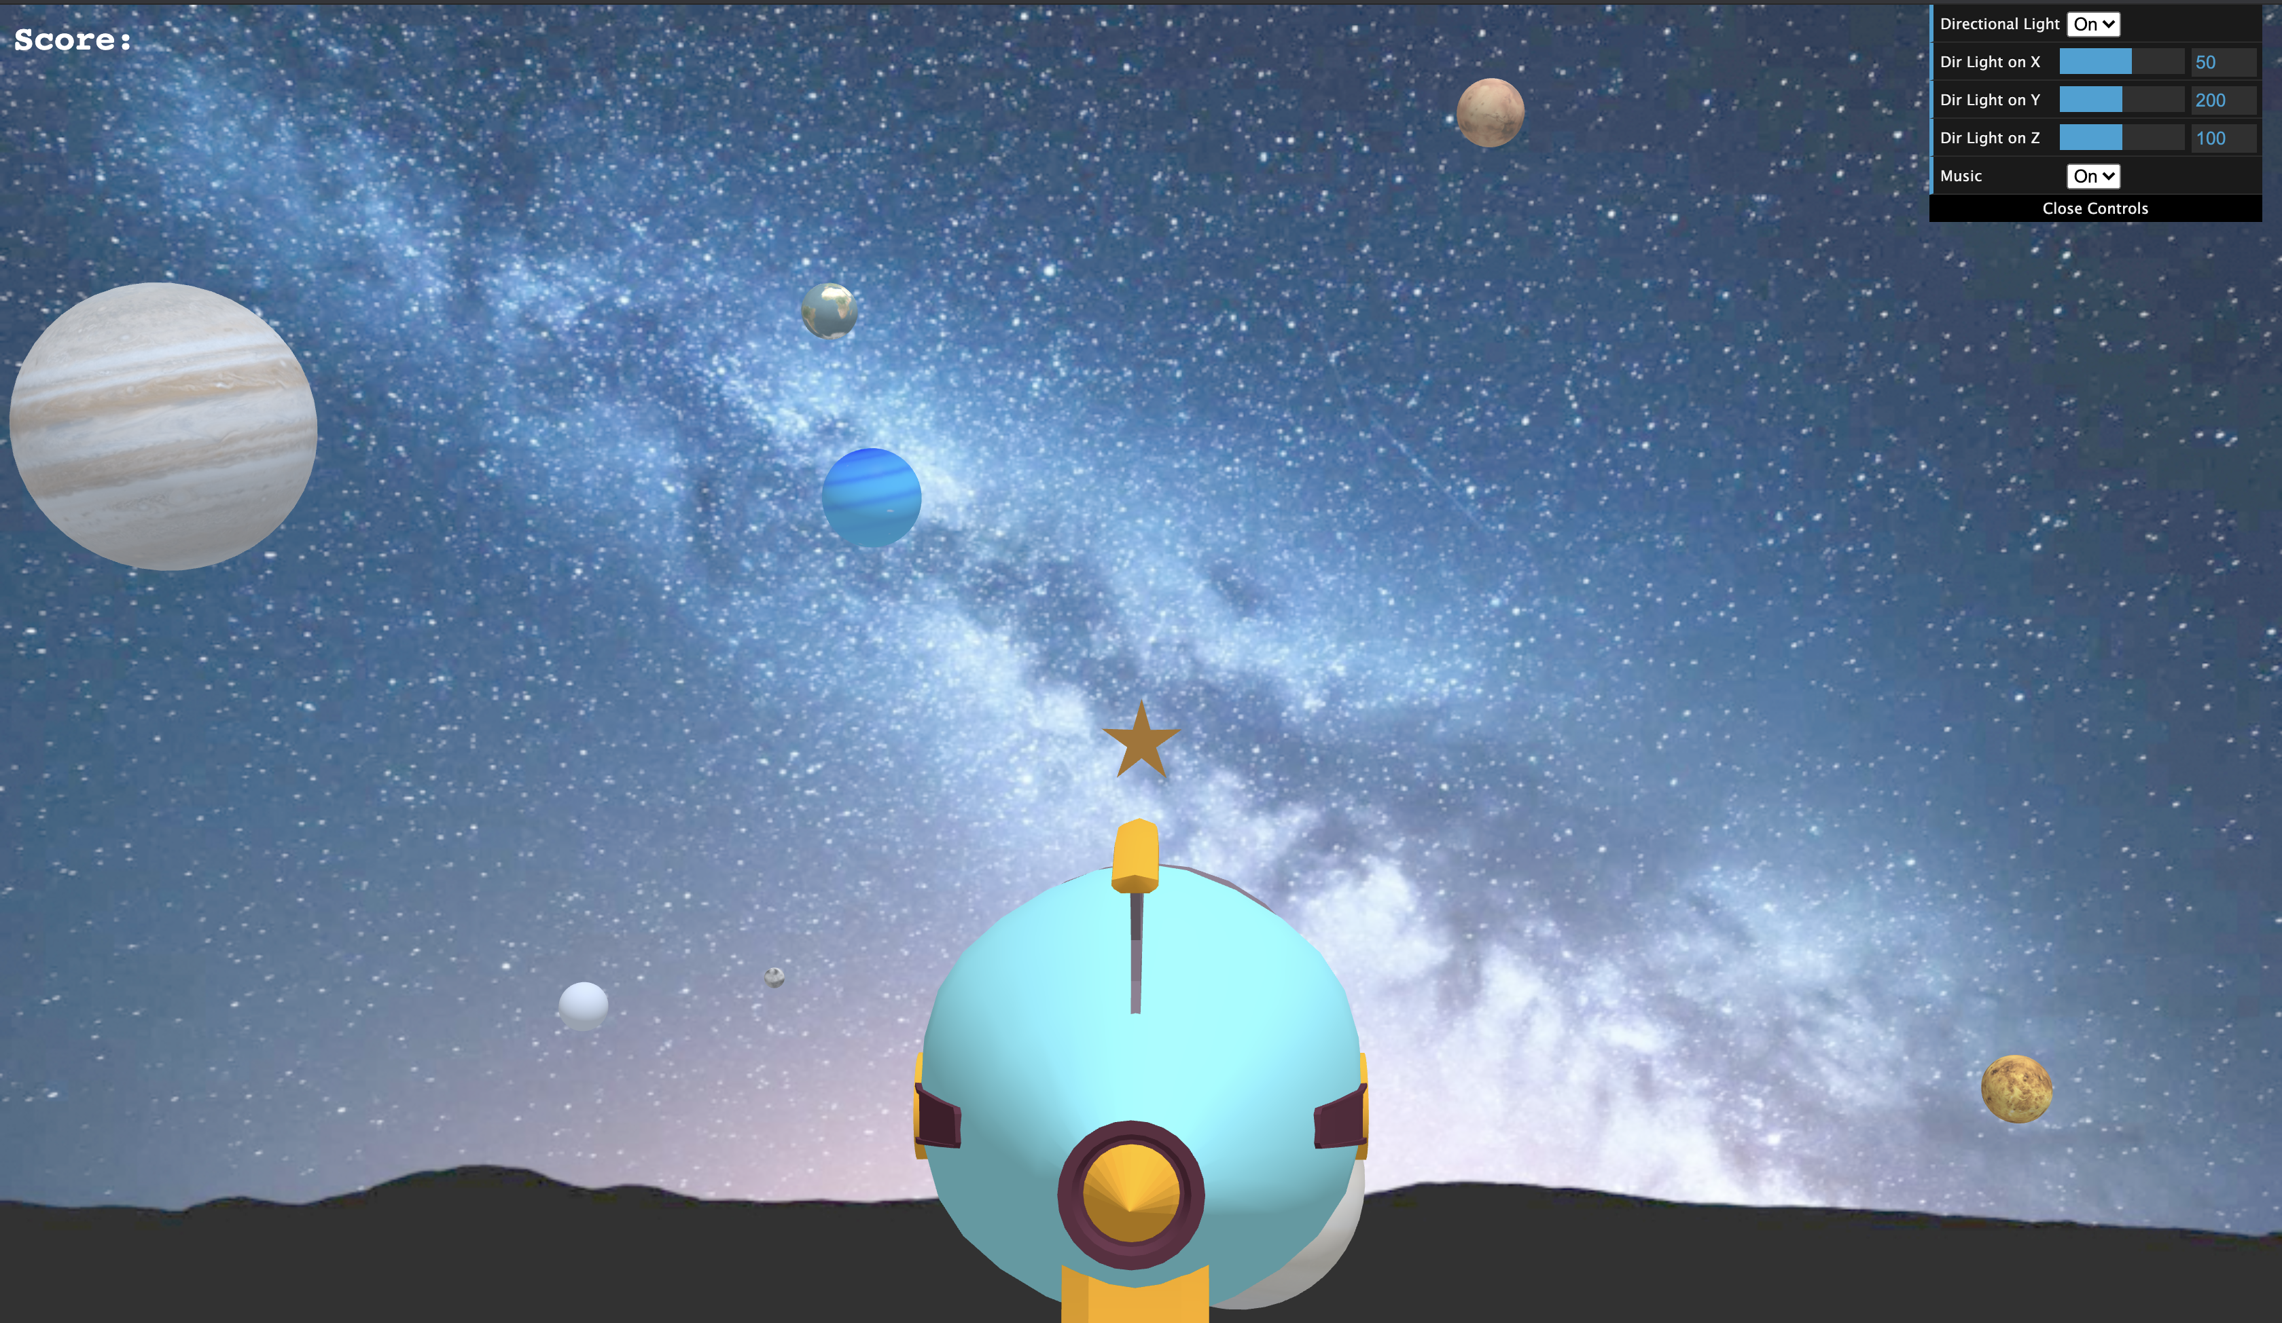

5. Bowling

5.1 Physijs: plugin for Three.js

Physijs brings a very easy to use interface to the three.js framework. It makes physics simulations just as easy to run. In fact, there are some steps that must be taken to make a 3D scene come alive.

We need to have the ammo.js, physi.js, physijs_worker.js and three.js files within our folder structure or coding environment to use Physijs. It uses a web worker to use different threads for physics calculations.

In our case we have used Physijs to develop a third scene in order to realise a simulation of bowling game. The user’s goal to give strength to the ball so that the object can fall. As we can see, we have that the camera follows the ball during the path.

5.2 Functions and functionality

In this scene, our goal was to simulate bowling game so the user has to do strike using the ball. The targets effect when the ball collides the pins, was realised thanks to Physijs.

In order to implement the functionality of the game, we have written our code inside of the js script; we have set camera, light (Ambient and Directional) and renderer.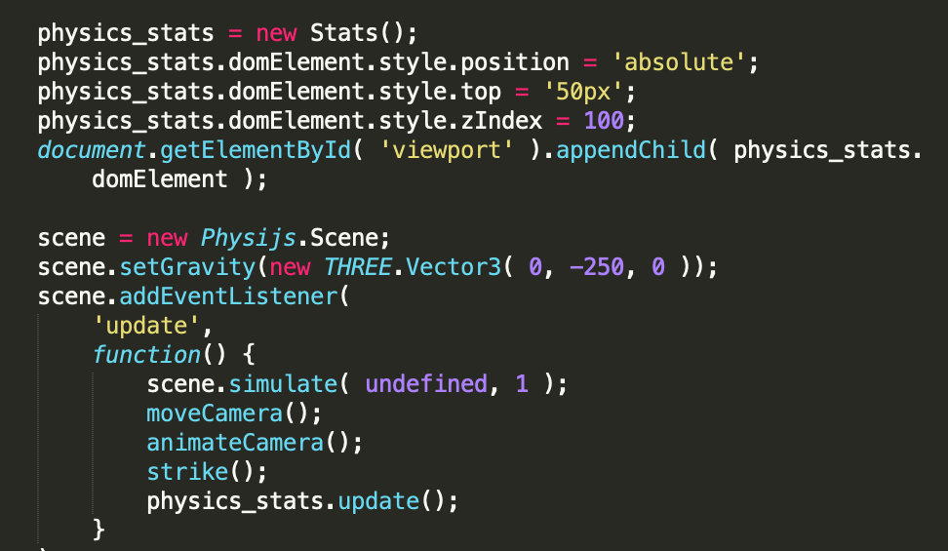

Thanks to physijs.scene we create the scene and with setGravity we are setting the gravity since each object in the physijs scene has to have a gravity value.

scene.AddEventListener gives us the possibility to set a listener in the scene and with update I send back the function every time something changes; as you can see, I refer to all the main functions.

With makeBoarder( x, z, w, h) and makeScore( x, z, w, h), the first one allows us to build our track as a polygon by inserting the measurements to give the correct dimensions to our structure. Obviously the idea was to best simulate a bowling alley while with the second one we were able to insert a dummy board to make the scene more realistic.

In order to create a pin, that will be our targets, and to set in the right way the position of each of them, we have declared the size and loaded a texture.We had to use addEventListener in order to insert a control collision on the box when is hit by the ball. Here, we have used the functions to add music effect.

The item ball is created thanks to SphereMesh inserting the weight. For all object we have a weight to set. Using ball.setLinearFactor(new THREE.Vector3( 0, 0, 0 )); we provide the possibility of movement only on X and Z.

With changePowerLine( ) , when I click on the ball, it gives me the ability to see the direction of my shot based on how much load on the ball is.

mouseDownHandler( ), mouseMoveHandler( ) and mouseUpHandler( ) are functions with which we manipulate the ball, that is the ball and the power line. They are the handlers for shooting the ball: I direct the power and do the opposite vector multiplied by a scalar based on the length of the defined line.

In order to manage the animation of the camera, we have implemented animateCamera( ) where in the first if we move the camera from the pins to the camera and then with camera.quaternion.slerp(targetOrientation, 0.1), we perform the animation. With moveCamera( ) the camera will follow the ball during is path.

Ritira( ) and home( ) are two function in order to show the writings on the right part of the screen, which are clickable, in order to retry to play or go to home and choose another game.

6. User’s interactions

6.1 Audio

To make the user experience as realistic as possible, we decided to introduce a general sound during the game experience and in particular when I’m using the gun, each one has his specific sound. Obviously the user can decide to put on pause the general sound by using the controls menu and when he wants he can restart it. This has been possible thanks to Three.AudioLoader, we have created an AudioListener and added it to camera. Then we have created a global audio source Three.Audio and finally we have loaded a sound and planned it as the Audio object’s buffer.

In order to reproduce sound correctly, we have implemented several different functions for each game modality and each gun.

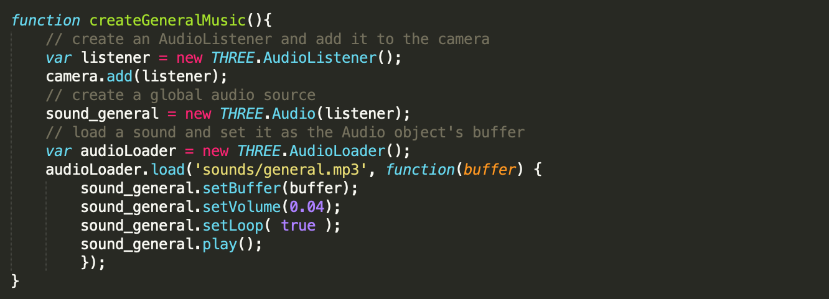

We have inserted this snipped code to show how we have managed the audio experience. For the scene sound, we plan sound_general.setLoop(true) to make the playback loop, obviously it starts when I start one of the possible game scenes.

In general we will use a different music function for each effect we want.

6.2 Controls menu

In order to manage the effects of directional light on the scene and therefore on the models inside it, we have created what is a menu that can hide itself, thanks to which the user is able to manage in a very simple way the degree of light in according to his tastes. Eventually it is possible to turn off the general music. 

The management of this layout is done in the function initGui( ).

6.3 Resizing the window

To make the user experience more enjoyable we added event handlers for resizing the window. Since the canvas is fullscreen, here we simply use the window’s client area. The camera also need to be notified of the changed aspect ratio. This is important or everything looks squashed. Since the camera can not detect that one of its properties changed, we need to call updateProjectionMatrix( ) function.

6.4 Commands

To manage the gun and to enjoy the experience, the user can interact with the keyboard and mouse.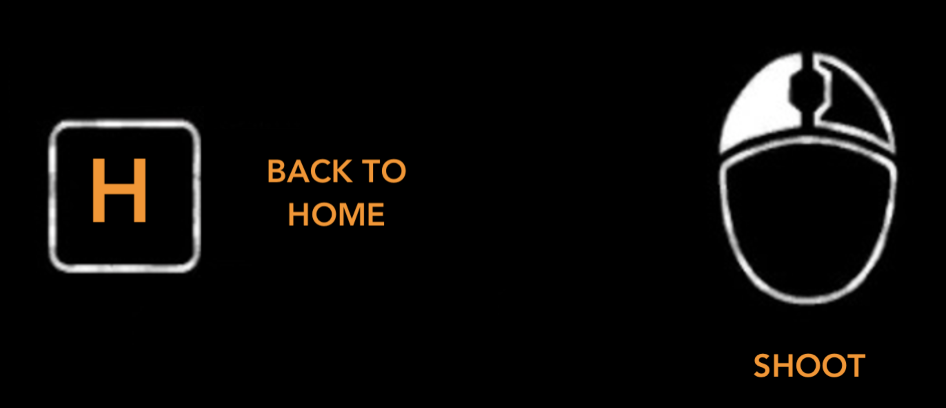

7. Bibliography

References